Lab 3-Stacks and Queues

Hung Manh, An Nguyen, Albert Cho

31 May 2021

Task 1:

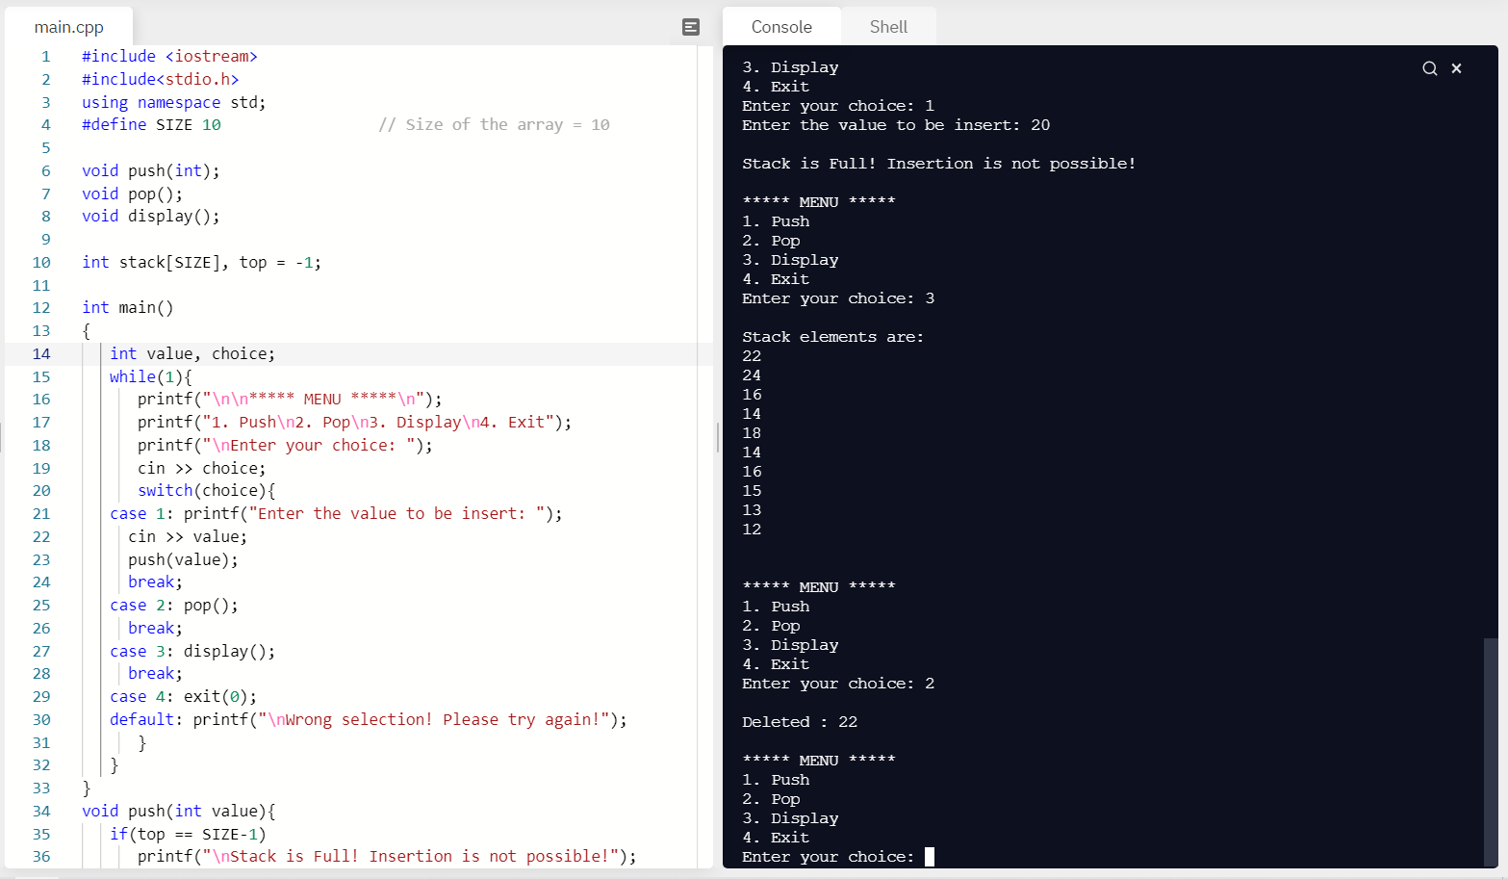

Task 2:

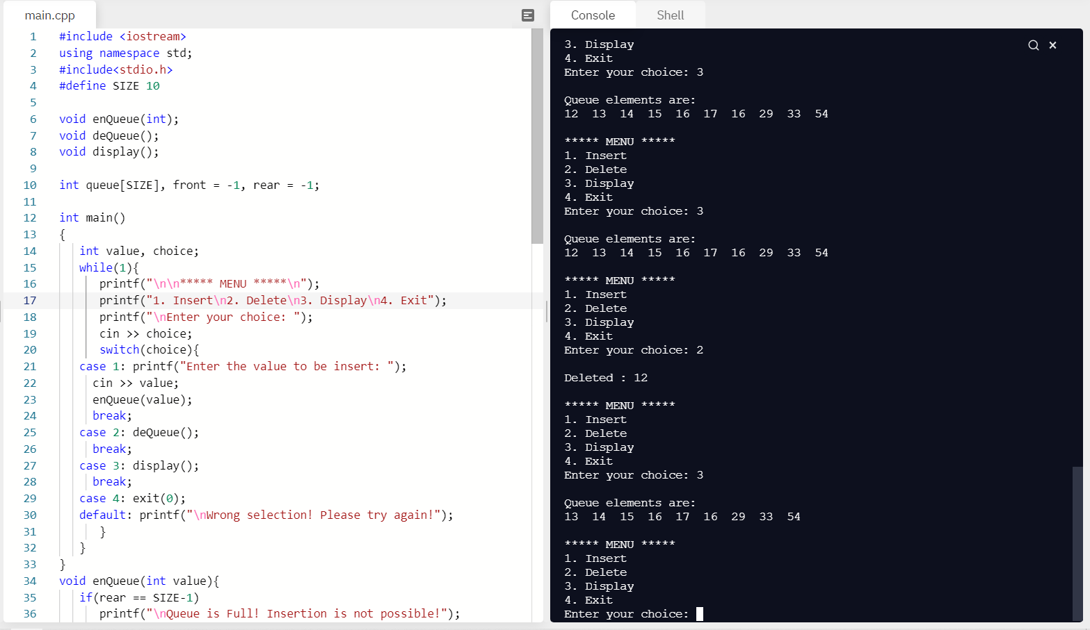

Task 3:

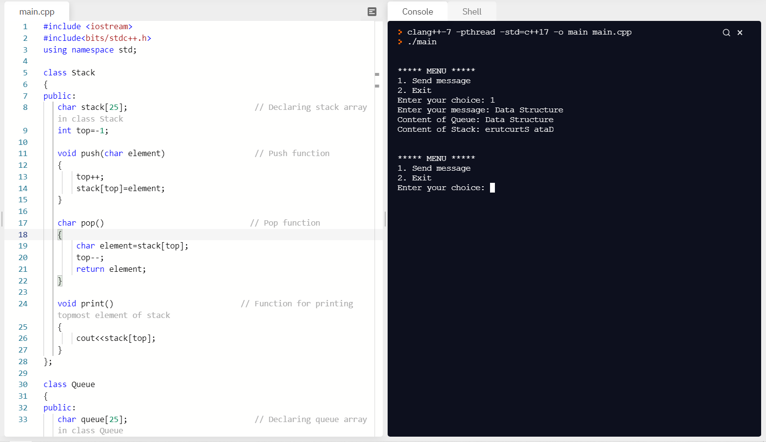

In this task, we use the application that we have been using in task 1 and 2 to accomplish this task. It is also using the same concept from those two so that it is not quite hard. However, in the task 3 it is not value like the others, we have to find the way to code it for character.

Conclusion: The objective explored in this assignment was to examine array based on stacks and queues. We think this this important to this course because it is easier to manage our data and see where we can add or remove items from the stack.

Team Evaluation: We met May 30, 2021 through video call, and we all contributed to the coding. Hung was able to code the header, Albert wrote the main code, and An modified the main code for it run properly. The grade for all of us should be an equal 100.